Project Proposal Template
Agentic AI Applications Course

Team Number:
Team Member Name (s): Amisha Vanditha
Chethan R
Akhilesh M Sagar

Proposed Project Title: Agentic Pharmacy: AI-Driven Inventory & Safety System

1. Problem Statement & Use Case: Your problem statement should answer the following questions clearly:
- What real-world problem are you solving?
Manual inventory management in pharmacies is prone to human error, specifically regarding the tracking of expiry dates and batch numbers, which can lead to the accidental sale of expired medicine.

- Who is the target user / beneficiary?
Small-to-medium independent pharmacists and pharmacy technicians.

- What currently happens (manual process, existing tools, pain points)?
Pharmacists manually check shelves and log data into basic spreadsheets, a process that is time-consuming and often misses near-expiry items until it is too late.

- Why is this a good fit for an agentic AI solution (vs a simple LLM prompt / RAG chatbot?)
Unlike a basic chatbot, this system requires autonomy to visually extract complex data from varied label formats and planning to coordinate between vision processing, SQL inventory updates, and clinical safety searches.

For example, below are some good problem statements and use cases:
- “Freelancers spend 4–8 hours/week chasing late invoice payments and reconciling partial payments. Existing tools (QuickBooks, FreshBooks) send reminders but don’t negotiate, follow-up intelligently, or escalate based on client history.”
- “Researchers waste hours finding, reading, and synthesizing recent papers on niche topics. Current tools (Elicit, Research Rabbit) help discovery but don’t produce structured literature reviews with critical analysis.”

2. Justify that your application is Agentic?
Explain why your application needs autonomy, iteration, tools, planning, reflection, and/or multi-agent collaboration
Core Agentic Capabilities:
* Tool Use: Interacting with a PostgreSQL database for inventory and ChromaDB for clinical knowledge.
* Reflection & Self-Correction: Using exponential backoff logic to autonomously handle API rate limits (429 errors) during bulk image processing.
* Planning & Decomposition: A semantic router that breaks down user queries into specific technical tasks (Vision, DB Query, or RAG).
* What would fail if it were a single LLM? A single LLM call would lack the persistent memory required to maintain a real-time inventory and would be unable to perform deterministic date calculations against a cloud database.
* Expected Agentic Behavior: When a user scans a label, the agent should recognize the medicine, check it against the existing database, and if a date conflict is found, reflect on the data to confirm the correct entry.

3. High-Level Solution Overview
* Main Agents:
* Router: Classifies intent and directs the flow.
* Vision Specialist: Extracts structured data from label images.
* Inventory Manager: Performs SQL operations on the PostgreSQL database.
* Clinical Researcher: Conducts RAG-based searches for medical safety queries.
* Key Patterns:
* Tool Use: Python-based database drivers and Google GenAI SDK.
* Memory Strategy: ChromaDB for long-term clinical knowledge and PostgreSQL for structured inventory state.
* Flow: User Query \rightarrow Router identifies intent \rightarrow Specialist executes tool \rightarrow Response synthesized with current date grounding.
4. Proposed Technology Stack
* LLM Provider: Gemini 2.5 Flash-Lite for cost-effective, high-throughput multimodal processing.
* Core Framework: LangGraph for state management and cyclic agentic flows.
* Vector DB: ChromaDB for unstructured clinical guidelines.
* Frontend: Streamlit for a three-tab dashboard (Chat, Inventory, and Alerts).
* Deployment: GitHub for version control and potential Streamlit Cloud hosting.
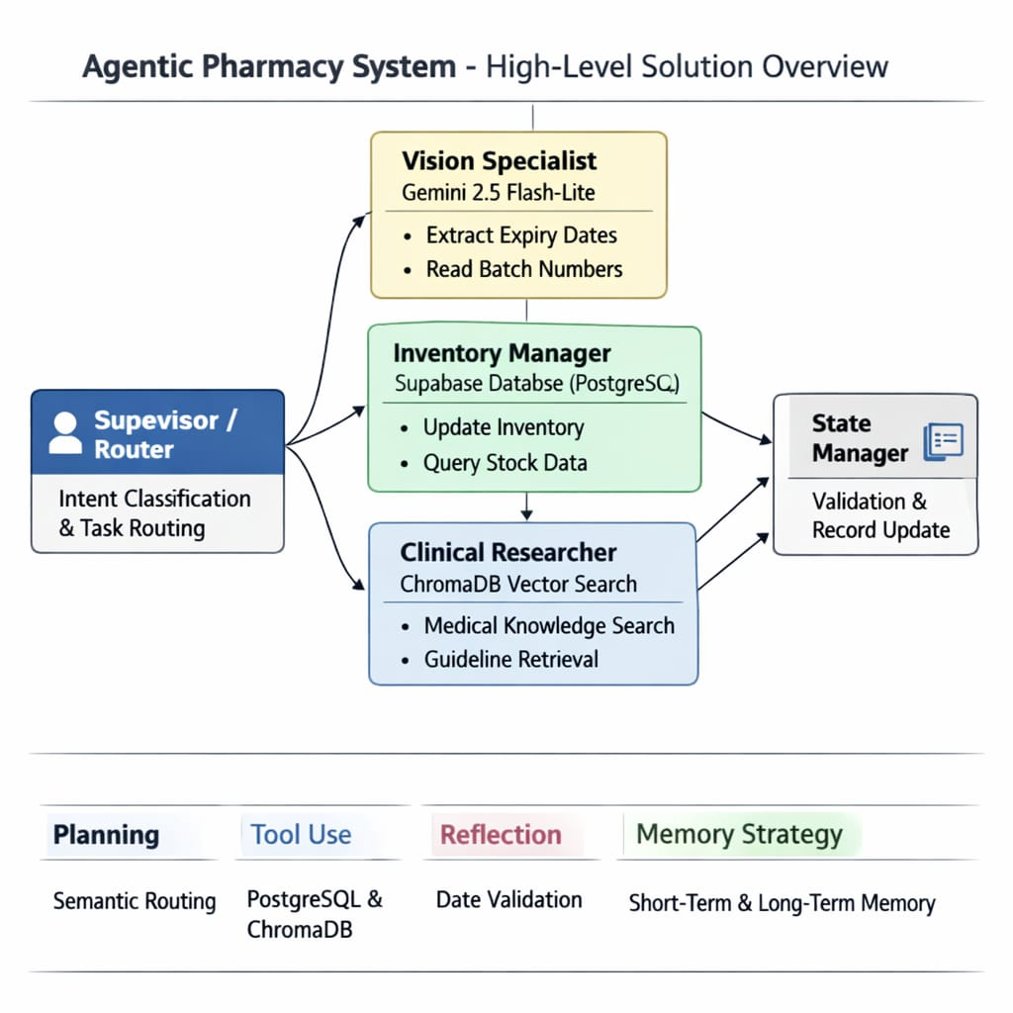

4. Proposed Technology Stack
* LLM Provider: Gemini 2.5 Flash-Lite for cost-effective, high-throughput multimodal processing.
* Core Framework: LangGraph for state management and cyclic agentic flows.
* Vector DB: ChromaDB for unstructured clinical guidelines.
* Frontend: Streamlit for a three-tab dashboard (Chat, Inventory, and Alerts).
* Deployment: GitHub for version control and potential Streamlit Cloud hosting.

5. Success Metrics & Evaluation Plan (≈ ½ page)
* Quantitative Metrics:
* Task Success Rate: Percentage of medicine labels correctly extracted and logged without manual intervention (Aim: >90%).
* Tool-Call Accuracy: Measuring how often the Router correctly identifies the necessary database or vision node.
* Qualitative Metrics:
* User Satisfaction: Mini user study focusing on the "Square Box" category UX.
* Safety Rubric: Human evaluation of clinical answers to ensure zero hallucinations in medical advice.

6. Risks, Challenges & Mitigation Plan
* Hallucinations on Expiry Dates: Mitigated by injecting the current system date into every prompt for precise temporal reasoning.
* Vision Data Inconsistency: Mitigated by a Reflection Loop that cross-references label text with user-provided hints.
* API Rate Limits: Mitigated by implementing exponential backoff with jitter to handle 429 errors autonomously.

7. Timeline & Milestones
* By Mar 25 (Demo 1): Vision node prototype with PostgreSQL logging and basic grounding.
* By Apr 10 (Document 2): Full architecture with Semantic Router and ChromaDB RAG integration.
* By Apr 22 (Demo 2): Multi-tab Streamlit dashboard with "Square Box" UX and automated expiry audit view.
* By May 5 (Final): Polished product with final evaluation metrics and technical documentation

